Weblogic Server 14c Notes

Creating a domain

In case the domain is not created during the installation, you need to create the domain, for that follow the steps

1. Open cmd as Admin
2. Navigate to C:\Oracle\Middleware\Oracle_Home\wlserver\common\bin
3. Type config.cmd and hit enter
4. You will get the wizard & just follow the steps & make sure you start the admin server, enter password Welcome123

Once the domain is created you need to goto the user_projects in case the domain name is base_domain navigate till the bin folder

i.e., C:\Oracle\Middleware\Oracle_Home\user_projects\domains\base_domain

Open the startWeblogic.cmd from the Admin cmd and in the browser enter <http://localhost:7001/console>

You might see The original administration console is no longer supported in WebLogic Server 14.1.2.0.0 and has been removed.

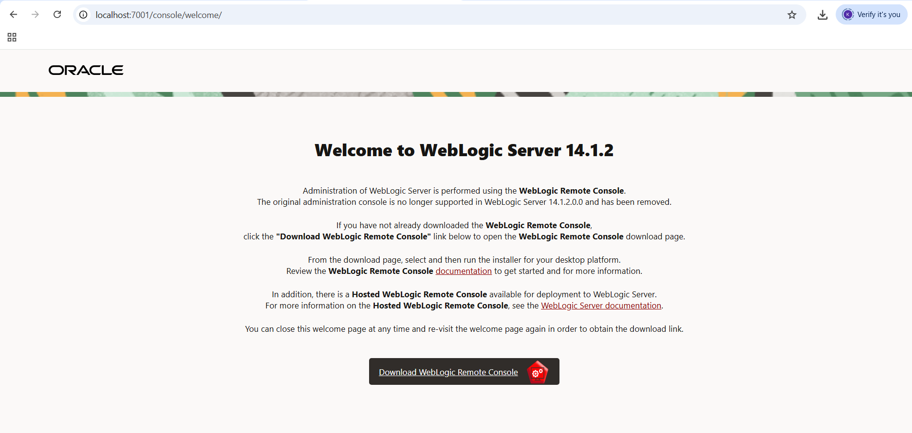

Click on the Download Weblogic Remote Console page and you will be taken to the download page

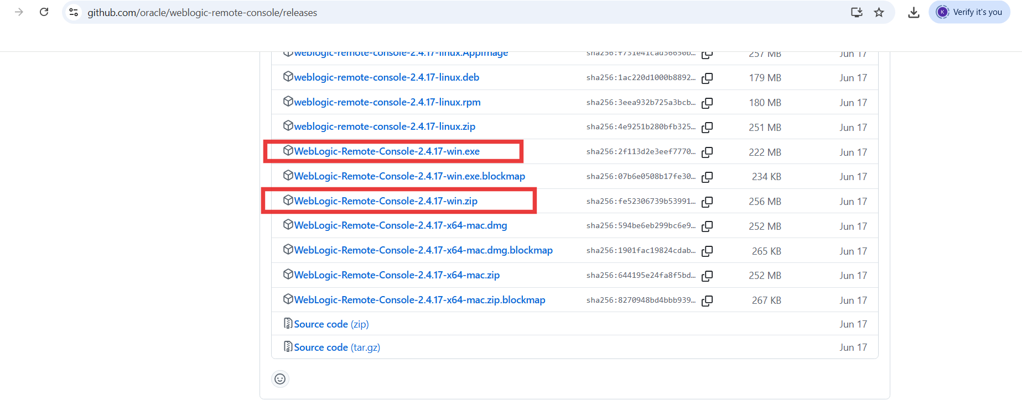

Download the .exe

Install exe file so that you get the app installed in your machine & its short cut gets created in the desktop which looks like as below.

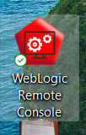

Note: create in users folder password.txt file and enter the password as below

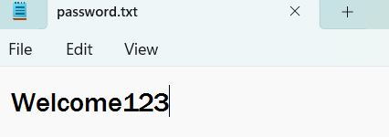

As the Admin server is running you would able to connect to this but first you must enter below commands in admin cmd

Below command is in one line, give space between each command that comes in new line

wlst.cmd C:\Oracle\Middleware\Oracle_Home\wlserver\server\bin\remote_console_deployment.py t3://localhost:7001 weblogic < C:\password.txt

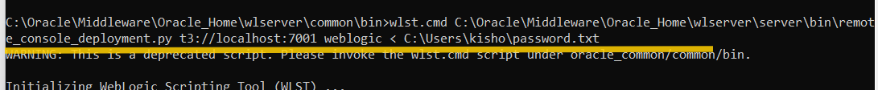

now open the Weblogic Remote Console

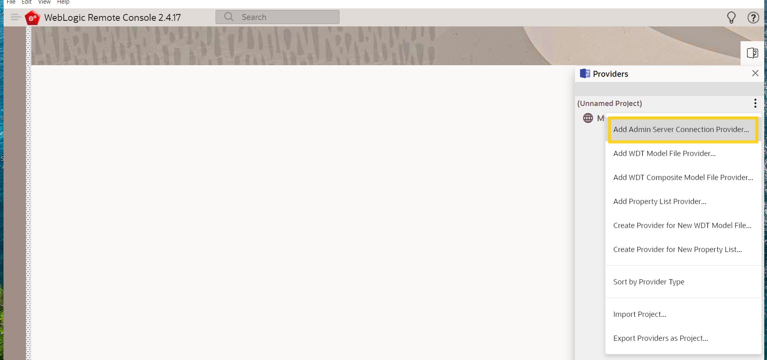

Select the Add Admin Server Connection Provider

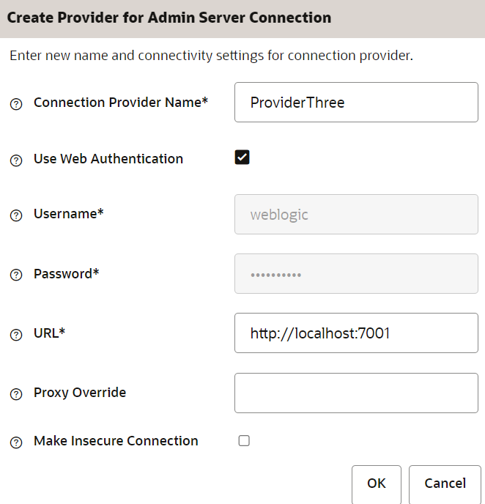

You can select Web Authentication, so that it opens a webpage where you can enter username & password >> you see token created message

Once you authenticate in the web page, you must be able to see the Remote Console to see the weblogic server console

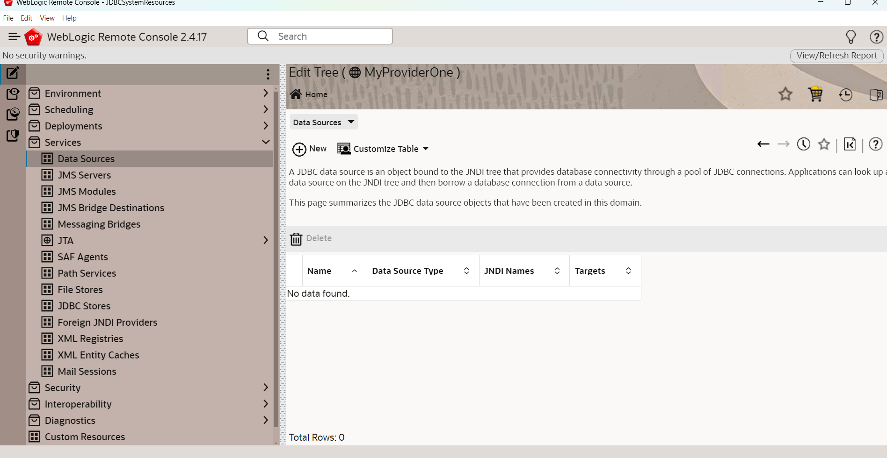

Creating the datasource in weblogic that can be used in your application

Services -> Datasources -> New ->

Name: myjdbcresource  
JNDI Name: jdbc/myds  
Target -> Select Admin Server > Push to right  
Datasource Type: Generic Datasource  
Database Type: Oracle  
Database Driver: *Oracle's Driver (Thin XA) for Service connections; Versions:Any  
Databae Name: ORCL  
Hostname: localhost  
Port: 1521  
Username & Password: Enter your db credentials  
>> Click create which you can see on top

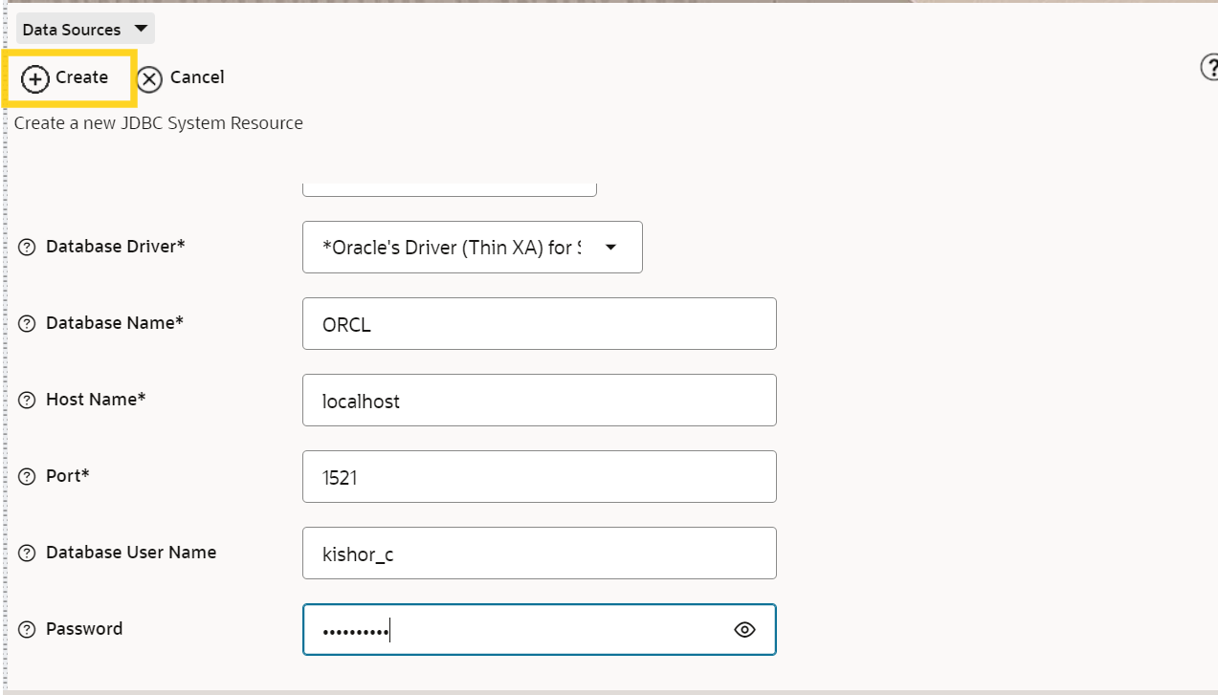

When you click on Test Configuration you must see a successful message

